Automated Light-Heavy Detection & Stress Analysis in Longer Chukchansi Words

Introduction
The Chukchansi Yokuts language originates from the northern part of Fresno, California. There were less than a dozen active fluent speakers remaining only a decade ago, and as of 2026, Holly Wyatt is the last. She has been working tirelessly with linguists from Fresno State University to document what she remembers and record herself speaking her native tongue. All audio files used in this analysis were sourced from the online Chukchansi Speaking Dictionary (Adisasmito-Smith, N., Adisasmito-Smith, N., Wyatt, H., Wyatt, J., 2026), which was developed as a companion web app to the 6th edition of the Chukchansi Dictionary (Adisasmito-Smith, N., Wyatt, H., Wyatt, J., 2023).
The foundational analysis of Chukchansi stress by Thomas Lee Collard described penultimate primary stress, with secondary stress on closed syllables with raised pitch (Collard 1968). A recent paper by Jason Peed analyzed acoustic data in two and three syllable words, specifically focusing on pitch, intensity, duration, and spectral tilt as likely stress correlates. Peed concluded that pitch and intensity were the two meaningful stress correlates, and found that primary stress was quantity-insensitively placed on the penultimate syllable. His analysis also concluded that secondary stress was placed on antepenultimate heavy syllables in three-syllable words, but not antepenultimate light syllables in three-syllable words (Peed 2019).
The linguists working on the Chukchansi dictionary with Holly have since recorded audio of four-syllable and five-syllable words, so this paper aims to extend Peed’s analysis and determine if prior predictions hold true in the general case. This paper will also perform a statistical analysis of heavy-light syllable patterns in Chukchansi to determine whether the language discriminates against or prefers certain arrangements. If possible, stress patterns will be classified with an OT constraint ranking.

Data Processing
The Chukchansi writing system is mostly phonetic, so one group of letters generally correlates to one sound. Therefore, a python script was developed that uses regular expressions to automatically detect and analyze n-syllable words. The following regexps were used for consonant and vowel detection:
- [aeiou] detects a single vowel
- ch\'|ch|sh|[bcdfghjklmnpqrstvwxyz]\'|[bcdfghjklmnpqrstvwxyz]|ʔ detects consonants, using greedy consumption to prioritize multi-character consonants such as “ch'”, “sh”, or “l'”

Longer regular expressions were constructed programmatically using python f-strings. For example, ^{C}*{V}+{C}+{V}+{C}*$ exactly matches a two-syllable word (^{σσ}$). Two nuclei ({V}+) are required with at least one consonant between ({C}+), but the initial onset and final coda are optional ({C}*). Extending the pattern, ^{C}*{V}+{C}+{V}+{C}+{V}+{C}*$ exactly matches a three-syllable word, and so on for longer words. It should be noted that Chukchansi requires syllables to have onsets. However, this requirement was enforced further down the pipeline for the purposes of this analysis, and the more general pattern with an optional initial onset can flag typos in the dataset.
Regular expressions were tested for up to nine-syllable words. As of April of 2026, the dataset contained the following distribution:
- 78 one-syllable words
- 2656 two-syllable words
- 3729 three-syllable words
- 1046 four-syllable words
- 55 five-syllable words
- 16 six-syllable words
- 0 words with more than six syllables

Of these, any word containing a word-medial “sh” consonant cluster was omitted from the analysis due to ambiguity between “CVs.hV” and “CV.shV” syllabification that could not be resolved by an automated script.
Next, a simplistic greedy recursive parser was written to programmatically syllabify the consonant-vowel patterns. A variable-size scanning window was iterated over the CV patterns, consuming the largest possible syllable in each pass before checking for smaller patterns. The full formal algorithmic proof and an example walkthrough of a parse can be found in the appendix below, for those so interested. This parser is guaranteed to parse any well-formed sequence of consonants and vowels into syllables in accordance with Chukchansi’s restriction that every syllable must have an onset. It should be noted that Chukchansi does not allow superheavy syllables, but their inclusion in the parser allowed a later section of the script to flag typos in the dataset (indeed, such a typo was found).
Once a consonant-vowel pattern was parsed into syllables, the final step of the process converted them into a heavy-light patterns using the following substitutions:
- “CVVC” ⇒ superheavy syllable (should not occur, flag word for review)
- “CVC” ⇒ heavy syllable “H”, from closed syllable
- “CVV” ⇒ heavy syllable “H”, from long vowel
- “CV” ⇒ light syllable “L”, from open syllable

As an illustrative example of the whole process, consider the word “honok'honook'in”, the possessive form of “inchworm”. First, a regular expression converts the word into a consonant-vowel pattern. Then, the recursive parser syllabifies that pattern. Finally, the syllabification is converted into a heavy-light pattern. All together, the process produces this transformation:
honok'honook'in → CVCVCCVCVVCVC → CV.CVC.CV.CVV.CVC → LHLHH

Prior Analyses of Chukchansi Stress Patterns
With an automated process for determining the heavy-light pattern of a Chukchansi word, the full dataset can now be catalogued. Since prior analyses assume Chukchansi is trochaic (Collard 1968, Peed 2019), this analysis will proceed under the same assumption for now.
Collard and Peed agree that the penultimate syllable of a Chukchansi word always has primary stress, regardless of syllable weight. Peed further concluded that the final syllable never has secondary stress, and the antepenultimate syllable has secondary stress if and only if it is heavy. Though he did not analyze words longer than three syllables, Peed generalizes this to align with Collard’s claim that all pre-penultimate heavy syllables are stressed. This gives the following footing patterns under a trochaic analysis:
- 2-syllable word: (σσ)
- 3-syllable word: L(σσ) and (H)(σσ)
Which should then generalize to the following in four-syllable words:
- 4-syllable word: L(H)(σσ), (H)L(σσ), and either (H)(H)(σσ) or (H)H(σσ)
Peed left it as an open question whether LL sequences would be footed or not, since he did not have sufficient audio for acoustic analysis, so one might expect either LL(σσ) or (LL)(σσ). Collard believed that they would not be footed, but did not perform any acoustic analysis.

Statistical Analysis
Running the heavy-light analysis script on the full April 2026 dataset from the Chukchansi Speaking Dictionary gave the counts in the tables below. It should be noted that these counts do not quite sum to the totals given in the data processing section, since they omit bad parses (generally caused by typos) and cases with ambiguous word-medial “CVshV” sequences.

1-syllable words |  | 2-syllable words
H x74 |  | HH x1623 | LH x454
L x1 |  | HL x282 | LL x17

3-syllable words |  |  | 4-syllable words
HHH x459 | LLH x123 |  | HHHH x7 | LLHH x15 | LLLH x7
 | LHL x266 |  |  | HLLH x53 | LLHL x2
LHH x1304 | HLL x103 |  | LHHH x40 | HHLL x11 | LHLL x41
HLH x836 |  |  | HLHH x21 | LHLH x516 | HLLL x1
HHL x107 | LLL x15 |  | HHLH x143 | LHHL x16
 |  |  | HHHL x0 | HLHL x9 | LLLL x3

5-syllable words |  |  | 6-syllable words
HHHLH x13 | LHLHH x3 |  | LHHHHH x1 | LHLHLH x3
HHHLL x4 | LHLHL x1 |  | HLHHLH x1 | HLLHLL x1
LHHLH x4 | LHLLH x13 |  | HHLHHL x1 | LHLHLL x1
LHHLL x1 | LLHLH x3 |  |  | LHLLHL x2
HHLLH x3

Already, there are several interesting observations to make about the raw patterns. First, heavy syllables are strongly preferred in short words.
- 99% of 1-syllable words are H (sole exception “xi”, the indefinite demonstrative “that”)
- 61% of two-syllable words are HH (25% expected from even distribution)
Sequences of heavy syllables are still preferred in three-syllable-or-longer words, but the single most common pattern becomes alternating LH pairs. 49% of 4-syllable words are LHLH, instead of the 6% expected from an even distribution, and the few 6-syllable datapoints also seem to prefer LHLHLH.
Another interesting pattern is a flip in preference for penultimate syllable weight. Under an even distribution, all values in the following table would be expected to be roughly 50%:

 | 99% of 1-syll words have final H
82% of 2-syll words have penult H | 78% of 2-syll words have final H
71% of 3-syll words have penult H | 87% of 3-syll words have final H
26% of 4-syll words have penult H | 92% of 4-syll words have final H
29% of 5-syll words have penult H | 71% of 5-syll words have final H
20% of 6-syll words have penult H | 50% of 6-syll words have final H

Recall that the penult always carries primary stress, regardless of word length (Collard 1986, Peed 2019). Two and three syllable words prefer heavy penults, as might be expected, but longer words strongly prefer light penults. In contrast, words of all lengths overwhelmingly prefer a heavy final syllable (6-syllable words have a more even distribution, but there are only ten, compared to thousands of less-than-6-syllable words). One possible explanation is that short words without affixes tend to be H or HH, while affixes tend to force …LH at the end of longer words. More research would be needed to quantify such a correlation.
Given that the penultimate syllable will always have primary stress and the final syllable will never have stress, with an eye to the assumption that stress is trochaic (or at least wants to avoid stress clash with the penult), we can condense the data down by masking the final two syllables. This masking is mostly important to the acoustic analysis performed below, but it also helps illustrate the already-observed preference for LH and HH pairs.

3-syllable words |  |  | 4-syllable words
Hσσ: 1505 / 3198 (47.1%) |  |  | HHσσ: 161 / 885 (18.2%)
Lσσ: 1693 / 3198 (52.9%) |  |  | LHσσ: 613 / 885 (69.3%)
 |  |  | HLσσ: 84 / 885 (9.5%)
 |  |  | LLσσ: 27 / 885 (3.1%)

5-syllable words |  |  | 6-syllable words
HHHσσ: 17 / 45 (37.8%) |  |  | LHHHσσ: 1 / 10 (10.0%)
LHHσσ: 5 / 45 (11.1%) |  |  | HLHHσσ: 1 / 10 (10.0%)
HHLσσ: 3 / 45 (6.7%) |  |  | HHLHσσ: 1 / 10 (10.0%)
LHLσσ: 17 / 45 (37.8%) |  |  | LHLHσσ: 4 / 10 (40.0%)
LLHσσ: 3 / 45 (6.7%) |  |  | HLLHσσ: 1 / 10 (10.0%)
 |  |  | LHLLσσ: 2 / 10 (20.0%)

Words with an even number of syllables display a clear preference for sequences of LH and HH pairs, while 5-syllable words reveal a preference for left-aligned LH and HH pairs. These long words are clearly far from an even distribution, but even 3-syllable words show a statistically-significant preference for antepenultimate light syllables under a chi-square test:
χ2 = (1505-1599)² / 1599 + (1693-1599)² / 1599 = 11.012
where the critical value @ 1 degree of freedom is 3.841 (result greater than critical value ⇒ unlikely to be even distribution). This preference seems sensible as a symptom of stress clash avoidance, given that 3-syllable words tend to have a heavy penult with primary stress, as shown above. It is also another example of a preference for left-aligned LH and HH pairs in words with an odd number of syllables.

Acoustic Analysis
Pursuant to the goal of analyzing longer words than Jason Peed’s 3-syllable maximum, the list of syllabified words was cross-referenced with the list of audio files available in the Chukchansi Speaking Dictionary. This yielded audio for eighty-five 4-syllable words, two 5-syllable words, and zero 6-syllable words. The audio files were sorted according to their masked patterns, then loaded into Praat for analysis. Since Peed 2019 identified pitch and intensity as the two most meaningful stress correlates, the average pitch and maximum intensity of each syllable’s nucleus were analyzed with Praat’s built-in tools. Averaging the results yielded the following:
x2 LLσσ, x60 LHσσ, x7 HLσσ, x14 HHσσ (for 85 total 4-syllable audio files)
x1 HHHσσ, x1 LLHσσ (for 2 total 5-syllable audio files)

 | LLσσ Avg Pitch | LHσσ Avg Pitch | HLσσ Avg Pitch | HHσσ Avg Pitch
First Syllable | 186 Hz | 183 Hz | 194 Hz | 201 Hz
Second Syllable | 192 Hz | 200 Hz | 196 Hz | 208 Hz
Third Syllable | 196 Hz | 205 Hz | 190 Hz | 209 Hz
Fourth Syllable | 147 Hz | 165 Hz | 156 Hz | 170 Hz
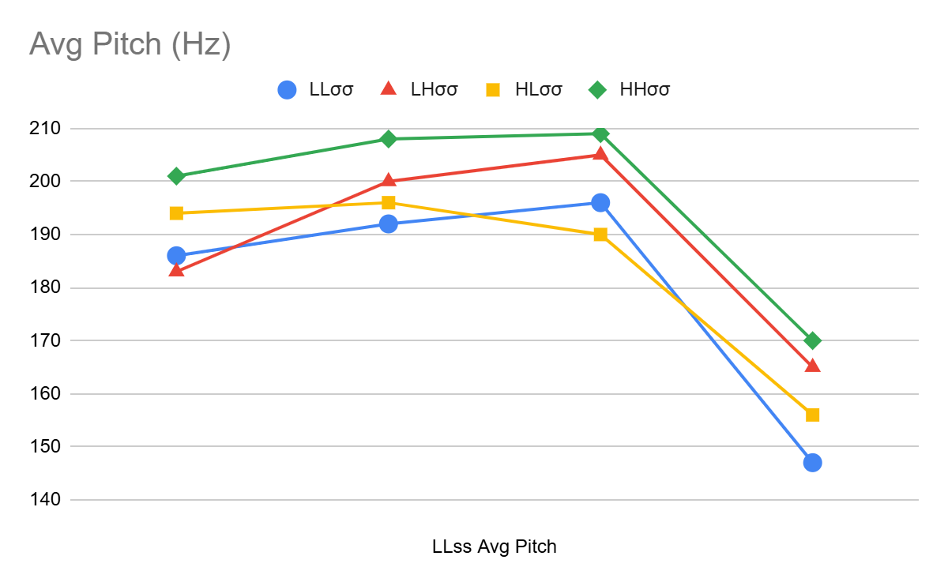
 | LLσσ Max Intens | LHσσ Max Intens | HLσσ Max Intens | HHσσ Max Intens
First Syllable | 76.3 dB | 71.7 dB | 72.3 dB | 71.7 dB
Second Syllable | 79.2 dB | 74.7 dB | 70.6 dB | 72.8 dB
Third Syllable | 79.6 dB | 74.3 dB | 69.8 dB | 74.4 dB
Fourth Syllable | 72.2 dB | 70.2 dB | 65.2 dB | 69.2 dB
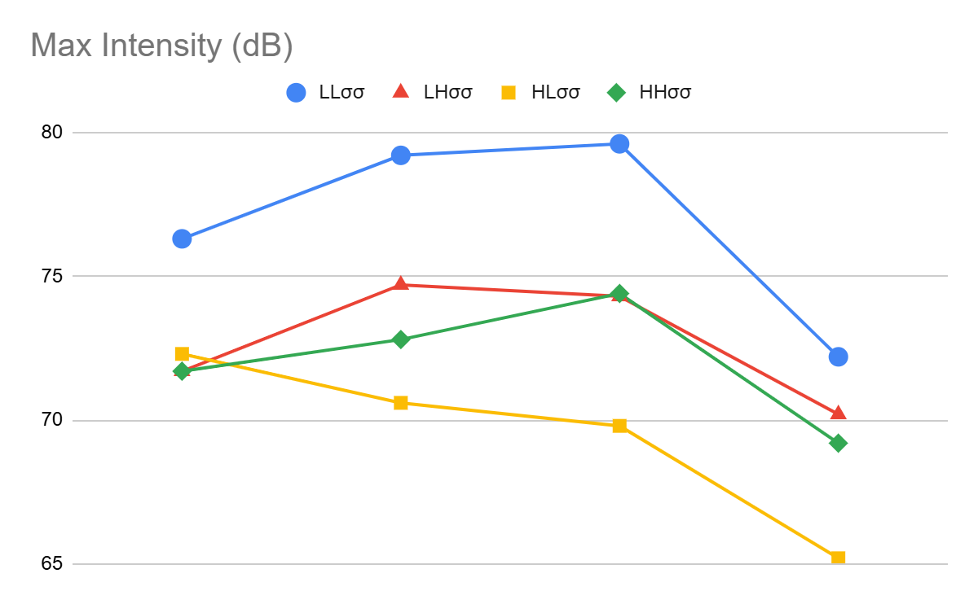
With 60 datapoints, the LHσσ progressions are the most trustworthy. Pitch rises monotonically until it peaks in the penultimate syllable, which is known to be the primary stress, while intensity peaks in the antepenultimate syllable. This could be an indication of secondary stress, forming the expected L(ˌH)(ˈσσ) pattern that Collard and Peed predict, while indicating that AlignHeadLeft >> WSP >> *Clash.
By contrast, both HHσσ (the second most trustworthy with 14 datapoints) and LLσσ (the least trustworthy with only 2 datapoints) have both pitch and intensity monotonically increasing up to the penult, with a 2341 pattern. This seems to indicate either that both have ..X. stress, or that both have .xX. stress. Neither of these indicate the (ˌH)H(ˈσσ) parse that would be expected under a trochaic analysis, which should generally be more optimal than H(ˌH)(ˈσσ) due to avoidance of stress clash. This contradicts the patterns predicted by Collard and Peed, and also calls into question the tentative ranking AlignHeadLeft >> WSP >> *Clash from above. This data could potentially also be viewed as an iambic (.x)(X). pattern if certain concessions are made. The possibility will be discussed in greater detail in the conclusions section below.
The HLσσ data (not very trustworthy with only 7 datapoints) muddies the waters even further. Even though Chukchansi is known to have penultimate primary stress, the penult did not exhibit a peak in pitch or intensity in the calculated averages. Examining the raw datapoints reveals a chaotic spread that does not have a clear enough backbone to pad against random jitter. In comparison, the HHσσ pitch data mostly follows a 2341 progression, and this trend has enough weight that the average aligns with it in spite of jitter from the remaining datapoints. More audio data is required to draw any meaningful conclusions about HLσσ stress.
There was audio for only two 5-syllable words, but their pitch and intensity peaked seemingly without correlation to each other, and without correlation to the expectation of penultimate primary stress.
It should be noted that the speaker Holly Wyatt had a general discomfort with being recorded, so some audio have non-natural stress patterns that are only padded out by large numbers of datapoints. This is why HLσσ and LLσσ averages in particular should be taken with a grain of salt. Holly also has allergies that occasionally result in vocal fry (also called rasp or creaky voice) at the beginning and end of words, which causes Praat to read an abnormally low pitch. For example, first-syllable pitch is always between 170 Hz and 230 Hz with the exception of 4 LHσσ audio files that Praat analyzed at 85-95 Hz. Although these outliers dragged the average pitch of the first syllable from 190 Hz when omitted to 183 Hz when included, the outliers did not change the overall 2341 pitch progression.

Conclusion
From the statistical analysis of heavy-light patterns, several notable patterns emerged about the distribution of weight. They are summarized here in brief:
- 1-syllable and 2-syllable words are composed almost entirely of heavy syllables
- most words have a final heavy syllable (whether or not they include an affix)
- 70% of 3-syllable words have penult H, while 70-80% of longer words have penult L
- words with an odd number of syllables tend to begin with an LH or HH pair
- words with an even number of syllables tend to begin with an LH or HH pair
- words with an even number of syllables also most commonly alternate LHLHLH
Given these observations, the first column of the following table constructs the statistically most common syllable weight patterns (the middle syllables of 5-syllable words had roughly even amounts of L and H, so it is simply rendered as σ). The second column then places stress and feet in accordance with Collard and Peed’s claim that the penultimate syllable always gets primary stress, while pre-penultimate heavy syllables attract secondary stress. The final column expands those expected feet to fill in the natural gaps in the pattern.

Most Common Pattern | Expected Stress/Footing | Expanded Feet
H | (ˈH) | (ˈH)
HH | (ˈH)H | (ˈH)H
LHH | L(ˈH)H | (LˈH)H
LHLH | L(ˌH)(ˈL)H | (LˌH)(ˈL)H
LHσLH | L(ˌH)σ(ˈL)H | (LˌH)(σˈL)H
LHLHLH | L(ˌH)L(ˌH)(ˈL)H | (LˌH)(LˌH)(ˈL)H

Footed in this way, the third column looks strikingly iambic, so long as the final syllable is explained away, perhaps as an extra-metrical attachment. However, this interpretation seems to describe right-aligned iambs, thus far unattested in natural language. There is no way to produce the emergent (.x)(.x)(X)σ pattern under the typology proposed by Birgit Alber (Alber 2005).
- R troc (x.)(x.)(x) when *Clash >> AllFeetLeft
- L troc (x)(x.)(x.) when AllFeetLeft >> *Clash
- L iamb (x)(.x)(x.) when neither dominates the other
- R iamb (.x)(.x)(x) never predicted given only these constraints

In spite of this difficulty, the previously-expected stress patterns from the second column also cannot be taken at face value. Given that natural languages are widely understood to minimize stress clash when possible, a (ˌH)H(ˈσσ) parse should theoretically be optimal. However, the acoustic analysis seems to show that whether HHσσ words are parsed with a ..X. or .xX. pattern, the first syllable is unambiguously not stressed. There would have to be some other constraint at play pulling stress away from the initial syllable for this interpretation to make sense.
As is ever the case, more data is needed to draw any clear conclusion. Hopefully future research will have the opportunity to analyze audio from a larger batch of 5-syllable and 6-syllable words, to better study how stress patterns generalize in longer words.
References
Adisasmito-Smith, N., Wyatt, H., Wyatt, J., (2023). Chukchansi dictionary 6th edition.
Adisasmito-Smith, N., Adisasmito-Smith, N., Wyatt, H., Wyatt, J., (2026). Online Chukchansi Speaking Dictionary. https://ssirrikh.github.io/chukchansi/speaking-dictionary
Alber, B. (2005). Clash, Lapse and Directionality. Natural Language & Linguistic Theory, 23(3), 485–542.
Collord, T. L. (1968). Yokuts Grammar: Chukchansi. UC Berkeley.
Peed, J. G. (2019). A Study of Acoustic Correlates of Syllable Stress in Chukchansi Yokuts. ProQuest Dissertations & Theses.

Appendix: Code & Data Repository
Both the python code and acoustic data produced for this paper are available for public use under the MIT license from the following GitHub repository:
https://github.com/Ssirrikh/chukchansi-stress-research
The audio files are available in MP3 format from the online Chukchansi Speaking Dictionary or its corresponding GitHub repository. For high-quality WAV files, contact Niken Adisasmito-Smith or another member of the Chukchansi Language Revitalization Project.

Appendix: Syllabifier-Parser Proof & Walkthrough
Formal algorithmic proof for syllabifier-parser:
Base Case: empty string
Report success and terminate
Base Case: string length 1
Report error and terminate (no valid syllable; missing either onset or nucleus)
Base Case: string length 2
If match “CV”, consume light syllable “CV”, then report success and terminate
Else, report error and terminate (CC missing nucleus, VV and VC missing onset)
Base Case: string length 3
If can consume heavy syllable “CVC” or “CVV”, report success and terminate
Else, report error and terminate (all other options invalid, or missing nuc/ons)
Recursive Case: string length > 3
Try scanning window of size 5:
If match “CVVCC”, consume superheavy “CVVC” and recurse
(coda+ons border: final C guaranteed to be onset of next syllable)
If match “CVVCV”, consume heavy “CVV” and recurse
(ons+nuc: penultimate C guaranteed to be onset of next syllable)
Else, try scanning window of size 4:
If match “CVCC”, consume heavy “CVC” and recurse (coda+ons border)
If match “CVCV”, consume light “CV” and recurse (ons+nuc of next syll)
Else, report error and terminate (string does not begin with valid syllable)

As an illustrative example, consider a step-by-step parse of the word “honok'honook'in”, the possessive form of “inchworm”. The parser initially receives the consonant-vowel pattern “CVCVCCVCVVCVC”:

- ∅ | CVCVCCVCVVCVC length > 3, recursive case:
  - Window size 5 [CVCVC]CVCVVCVC → no match
  - Window size 4 [CVCV]CCVCVVCVC → match CVCV → consume CV
- CV | CVCCVCVVCVC length > 3, recursive case:
  - Window size 5 [CVCCV]CVVCVC → no match
  - Window size 4 [CVCC]VCVVCVC → match CVCC → consume CVC
- CV.CVC | CVCVVCVC length > 3, recursive case:
  - Window size 5 [CVCVV]CVC → no match
  - Window size 4 [CVCV]VCVC → match CVCV → consume CV
- CV.CVC.CV | CVVCVC length > 3, recursive case:
  - Window size 5 [CVVCV]C → match CVVCV → consume CVV
- CV.CVC.CV.CVV | CVC length = 3, base case:
  - [CVC] → match CVC → consume CVC → report success and terminate
- DONE, parser returns CV.CVC.CV.CVV.CVC

